
IQRA 1447
Level 1 · Extra Practice and Games · Teacher’s Guide
Print only the pages a child needs: every page is numbered at the bottom. Nothing here needs marking — each game shows its own mistakes.
What is in this file
Pages | What | Workbook sections | What the child does
1–2 | Teacher’s guide and answers | — | this page and the next: how each game runs, and the answers
3–7 | Extra Practice — the letters | 1–2 | each letter of Sections 1–2 written 10 times (3 traced, 7 on their own), one family of look-alike letters to a page
8–21 | Extra Practice — natural madd | 5 | all six forms of each letter written 10 times (3 traced, 7 on their own), two letters to a page
22–30 | Hidden Pictures | 1, 2, 3, 4, 5, 6 | read each box, color it by the rules, and a picture appears
31–33 | Connect the Dots | 1, 3, 4 | join the dots in an order the child knows, and an Islamic figure appears
Extra Practice — the letters
• Each letter of Sections 1 and 2, 10 times: 3 traced in gray, then 7 on its own. Each page is one family of letters that look alike, so you can copy just the page a child is stuck on.
• Natural madd: the workbook’s Section 5 page by page — every letter’s six forms (Fat-ha, Madd Alif, Damma, Madd Waaw, Kasra, Madd Yaa), each 10 times, two letters to a page, in the workbook’s order.
Hidden Pictures
• Read the color rules out loud once. Each child reads every box out loud, then colors it by the rules.
• To check, glance from the front of the room. A clean picture means every box was read right. A colored box out in the white, or a white box inside the picture, is a box read wrong: point to it, the child reads it to you and fixes it.
• Two crayons and a pencil are all a child needs. Black-and-white copies are fine: the colors are named on the sheet, never printed.

Page | Section | What it practices | Hidden picture
22 | 1 · The Letters | ب and ج among other letters | a crescent moon and a star
23 | 1 · The Letters | م and ف among other letters | the Kaaba
24 | 2 · Letters That Look Alike | ت and ث among ب ن ي | a masjid
25 | 2 · Letters That Look Alike | ج and ر among ح خ ع غ ز د ذ | a palm tree
26 | 3 · Harakat | Fat-ha and Damma (Kasra stays white) | the sun
27 | 3 · Harakat | Sukoon and Kasra among Fat-ha and Damma | a rain cloud
28 | 4 · Tanween | Tanween Fath and Tanween Damm among single harakat | a sailboat
29 | 5 · Natural Madd | Madd Alif and Madd Yaa among short harakat and Madd Waaw | an olive tree
30 | 6 · Shadda | Shadda with Fat-ha and with Kasra among no Shadda | a minaret
Connect the Dots
• The order is printed under the title, right to left, and every child already knows it: the alphabet song; then Fat-ha, Damma, Kasra on each letter; then the three tanween on each letter. Start at the dot with a ring, and end back at it.
• To check, look at the figure. A dot taken out of order is a line that cuts across the picture.
• When the figure is done, the child colors it in and says or writes what it is.

Page | Section | The order | The figure
31 | 1 · The Letters | the alphabet song | a masjid
32 | 3 · Harakat | Fat-ha, Damma, Kasra on each letter, from ب to ر | a crescent moon
33 | 4 · Tanween | Tanween Fath, Damm, Kasr on each letter, from ب to ذ | ۞, the Rub el Hizb star that marks each quarter of a hizb in the Mushaf
The answers
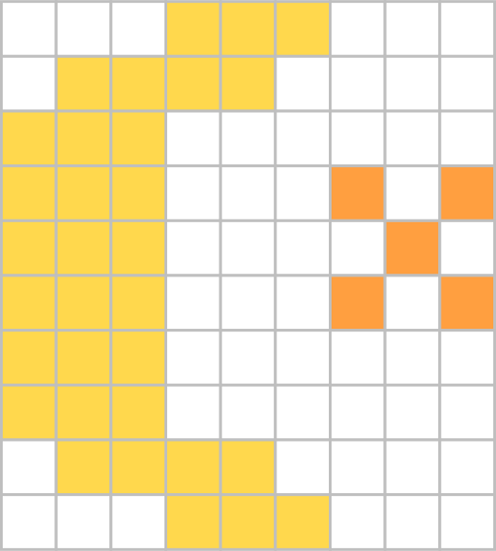  p. 22 crescent moon and a star | 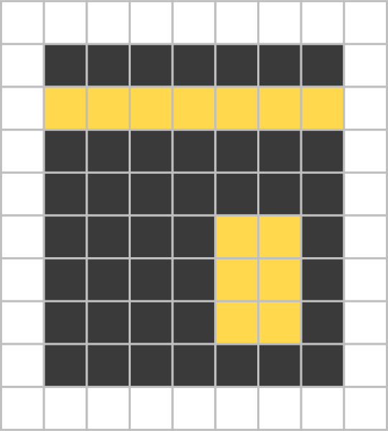  p. 23 Kaaba | 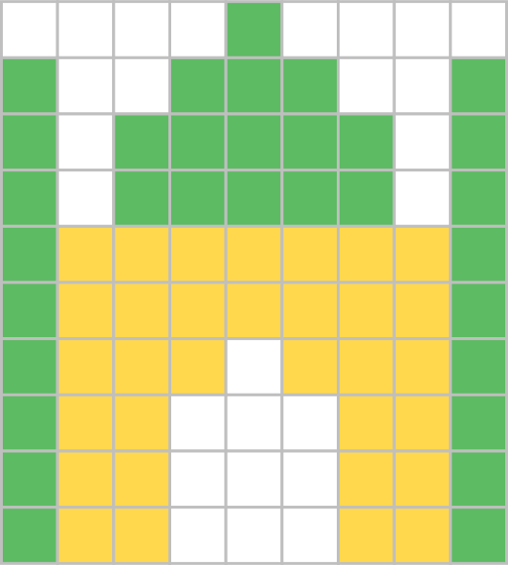  p. 24 masjid | 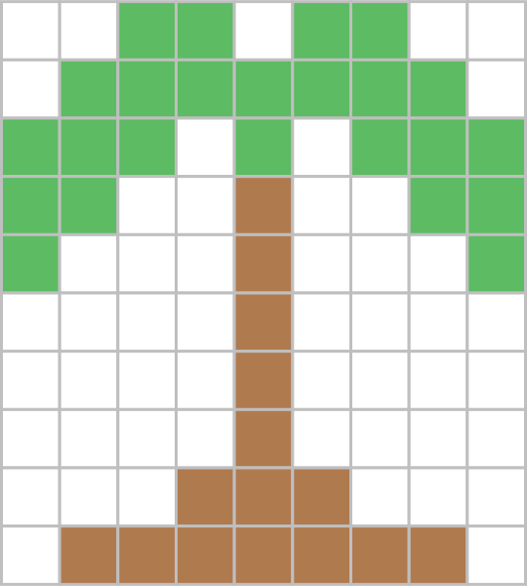  p. 25 palm tree | 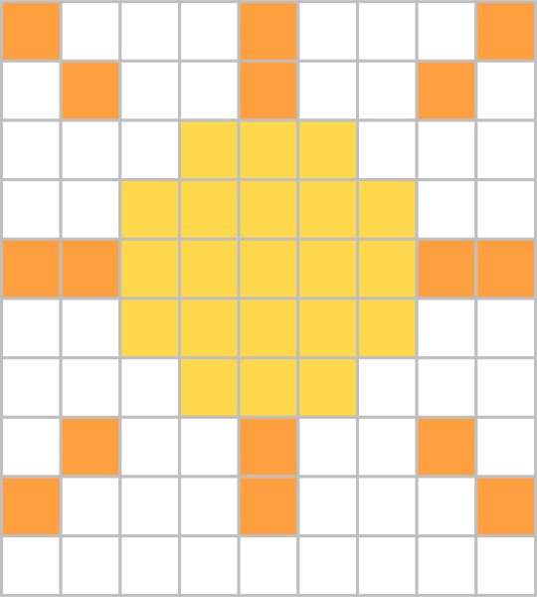  p. 26 sun
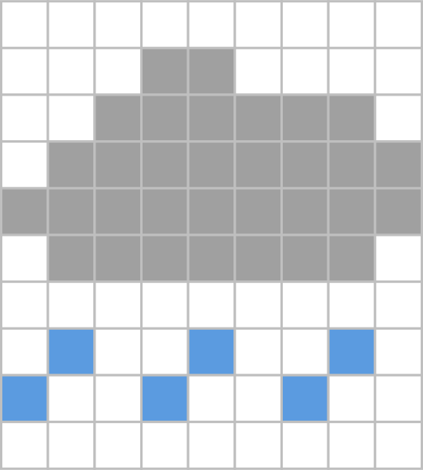  p. 27 rain cloud | 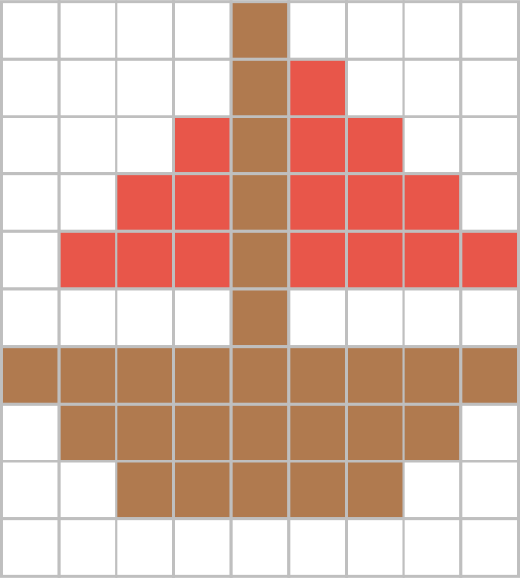  p. 28 sailboat | 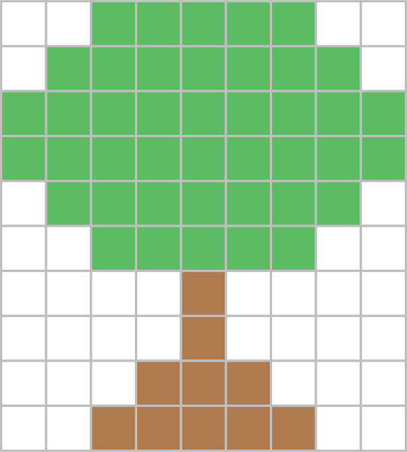  p. 29 olive tree | 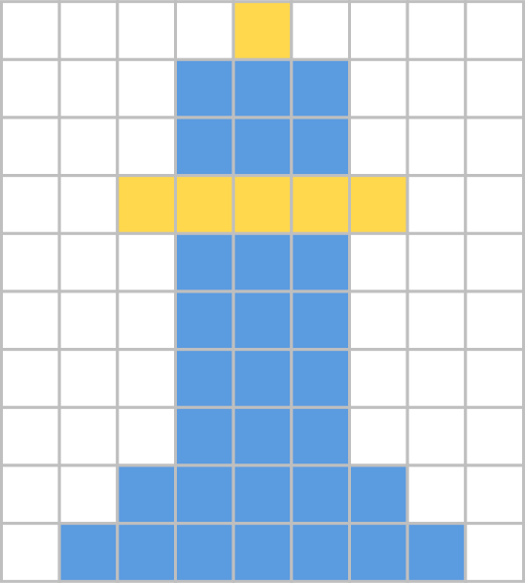  p. 30 minaret

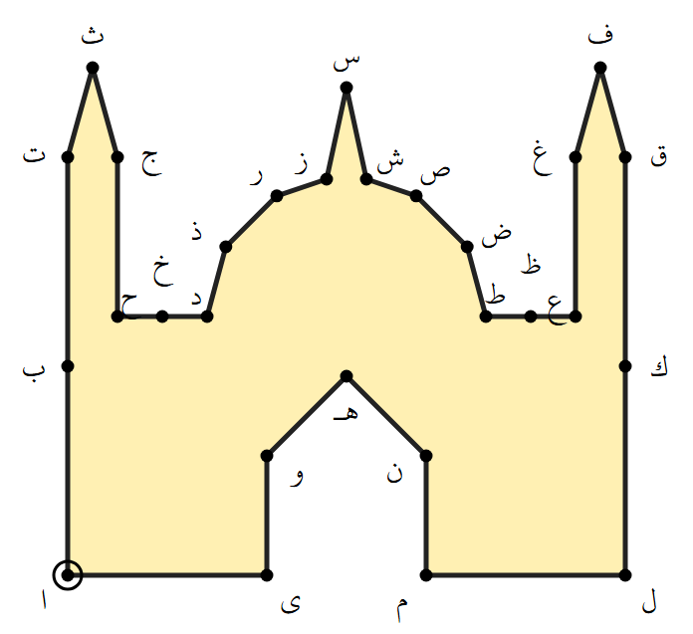  p. 31 masjid | 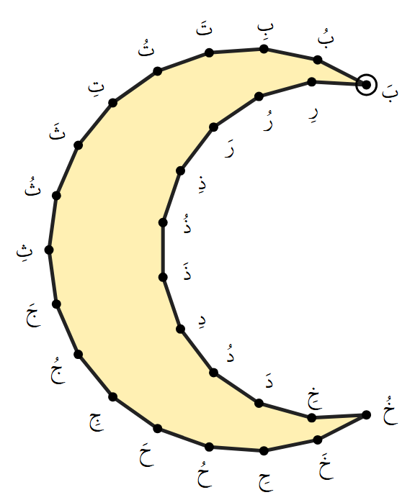  p. 32 crescent moon | 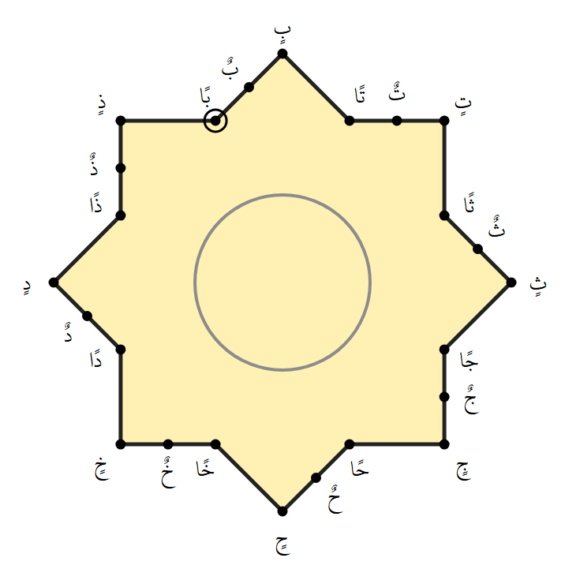  p. 33 Rub el Hizb star

IQRA 1447
Level 1 · Extra Practice · The Letters and Letters That Look Alike
Name: ________________________________________
Extra Practice 1 of 5 — Trace the gray letter 3 times, then write it 7 times on your own. Watch the dots!
ب | ت | ث | ن | ي
Baa | Taa | Thaa | Noon | Yaa
ب | ت | ث | ن | ي
ب | ت | ث | ن | ي
ب | ت | ث | ن | ي
IQRA 1447
Level 1 · Extra Practice · The Letters and Letters That Look Alike
Name: ________________________________________
Extra Practice 2 of 5 — Trace the gray letter 3 times, then write it 7 times on your own. Watch the dots!
ج | ح | خ | ع | غ | ء
Jeem | Ḥaa | Khaa | ʿAyn | Ghayn | Hamza
ج | ح | خ | ع | غ | ء
ج | ح | خ | ع | غ | ء
ج | ح | خ | ع | غ | ء
IQRA 1447
Level 1 · Extra Practice · The Letters and Letters That Look Alike
Name: ________________________________________
Extra Practice 3 of 5 — Trace the gray letter 3 times, then write it 7 times on your own. Watch the dots!
د | ذ | ر | ز | و | ف | ق
Daal | Dhaal | Raa | Zaay | Waaw | Faa | Qaaf
د | ذ | ر | ز | و | ف | ق
د | ذ | ر | ز | و | ف | ق
د | ذ | ر | ز | و | ف | ق
IQRA 1447
Level 1 · Extra Practice · The Letters and Letters That Look Alike
Name: ________________________________________
Extra Practice 4 of 5 — Trace the gray letter 3 times, then write it 7 times on your own. Watch the dots!
س | ش | ص | ض | ط | ظ
Seen | Sheen | Ṣaad | Ḍaad | Ṭaa | Ẓaa
س | ش | ص | ض | ط | ظ
س | ش | ص | ض | ط | ظ
س | ش | ص | ض | ط | ظ
IQRA 1447
Level 1 · Extra Practice · The Letters and Letters That Look Alike
Name: ________________________________________
Extra Practice 5 of 5 — Trace the gray letter 3 times, then write it 7 times on your own.
ا | ل | لا | ك | م | هـ
Alif | Laam | Laam-Alif | Kaaf | Meem | Haa
ا | ل | لا | ك | م | هـ
ا | ل | لا | ك | م | هـ
ا | ل | لا | ك | م | هـ
IQRA 1447
Level 1 · Extra Practice · Natural Madd
Name: ________________________________________
Natural Madd 1 of 14 · Section 5 — Trace each one 3 times, then write it 7 times on your own.
بَدَ | بَادَ | بُدَ | بُودَ | بِدَ | بِيدَ |  | تَدَ | تَادَ | تُدَ | تُودَ | تِدَ | تِيدَ
Fat-ha | Madd Alif | Damma | Madd Waaw | Kasra | Madd Yaa |  | Fat-ha | Madd Alif | Damma | Madd Waaw | Kasra | Madd Yaa
بَدَ | بَادَ | بُدَ | بُودَ | بِدَ | بِيدَ |  | تَدَ | تَادَ | تُدَ | تُودَ | تِدَ | تِيدَ
بَدَ | بَادَ | بُدَ | بُودَ | بِدَ | بِيدَ |  | تَدَ | تَادَ | تُدَ | تُودَ | تِدَ | تِيدَ
بَدَ | بَادَ | بُدَ | بُودَ | بِدَ | بِيدَ |  | تَدَ | تَادَ | تُدَ | تُودَ | تِدَ | تِيدَ
IQRA 1447
Level 1 · Extra Practice · Natural Madd
Name: ________________________________________
Natural Madd 2 of 14 · Section 5 — Trace each one 3 times, then write it 7 times on your own.
ثَدَ | ثَادَ | ثُدَ | ثُودَ | ثِدَ | ثِيدَ |  | جَدَ | جَادَ | جُدَ | جُودَ | جِدَ | جِيدَ
Fat-ha | Madd Alif | Damma | Madd Waaw | Kasra | Madd Yaa |  | Fat-ha | Madd Alif | Damma | Madd Waaw | Kasra | Madd Yaa
ثَدَ | ثَادَ | ثُدَ | ثُودَ | ثِدَ | ثِيدَ |  | جَدَ | جَادَ | جُدَ | جُودَ | جِدَ | جِيدَ
ثَدَ | ثَادَ | ثُدَ | ثُودَ | ثِدَ | ثِيدَ |  | جَدَ | جَادَ | جُدَ | جُودَ | جِدَ | جِيدَ
ثَدَ | ثَادَ | ثُدَ | ثُودَ | ثِدَ | ثِيدَ |  | جَدَ | جَادَ | جُدَ | جُودَ | جِدَ | جِيدَ
IQRA 1447
Level 1 · Extra Practice · Natural Madd
Name: ________________________________________
Natural Madd 3 of 14 · Section 5 — Trace each one 3 times, then write it 7 times on your own.
حَدُ | حَادُ | حُدُ | حُودُ | حِدُ | حِيدُ |  | خَدُ | خَادُ | خُدُ | خُودُ | خِدُ | خِيدُ
Fat-ha | Madd Alif | Damma | Madd Waaw | Kasra | Madd Yaa |  | Fat-ha | Madd Alif | Damma | Madd Waaw | Kasra | Madd Yaa
حَدُ | حَادُ | حُدُ | حُودُ | حِدُ | حِيدُ |  | خَدُ | خَادُ | خُدُ | خُودُ | خِدُ | خِيدُ
حَدُ | حَادُ | حُدُ | حُودُ | حِدُ | حِيدُ |  | خَدُ | خَادُ | خُدُ | خُودُ | خِدُ | خِيدُ
حَدُ | حَادُ | حُدُ | حُودُ | حِدُ | حِيدُ |  | خَدُ | خَادُ | خُدُ | خُودُ | خِدُ | خِيدُ
IQRA 1447
Level 1 · Extra Practice · Natural Madd
Name: ________________________________________
Natural Madd 4 of 14 · Section 5 — Trace each one 3 times, then write it 7 times on your own.
دَدُ | دَادُ | دُدُ | دُودُ | دِدُ | دِيدُ |  | ذَدُ | ذَادُ | ذُدُ | ذُودُ | ذِدُ | ذِيدُ
Fat-ha | Madd Alif | Damma | Madd Waaw | Kasra | Madd Yaa |  | Fat-ha | Madd Alif | Damma | Madd Waaw | Kasra | Madd Yaa
دَدُ | دَادُ | دُدُ | دُودُ | دِدُ | دِيدُ |  | ذَدُ | ذَادُ | ذُدُ | ذُودُ | ذِدُ | ذِيدُ
دَدُ | دَادُ | دُدُ | دُودُ | دِدُ | دِيدُ |  | ذَدُ | ذَادُ | ذُدُ | ذُودُ | ذِدُ | ذِيدُ
دَدُ | دَادُ | دُدُ | دُودُ | دِدُ | دِيدُ |  | ذَدُ | ذَادُ | ذُدُ | ذُودُ | ذِدُ | ذِيدُ
IQRA 1447
Level 1 · Extra Practice · Natural Madd
Name: ________________________________________
Natural Madd 5 of 14 · Section 5 — Trace each one 3 times, then write it 7 times on your own.
رَدِ | رَادِ | رُدِ | رُودِ | رِدِ | رِيدِ |  | زَدِ | زَادِ | زُدِ | زُودِ | زِدِ | زِيدِ
Fat-ha | Madd Alif | Damma | Madd Waaw | Kasra | Madd Yaa |  | Fat-ha | Madd Alif | Damma | Madd Waaw | Kasra | Madd Yaa
رَدِ | رَادِ | رُدِ | رُودِ | رِدِ | رِيدِ |  | زَدِ | زَادِ | زُدِ | زُودِ | زِدِ | زِيدِ
رَدِ | رَادِ | رُدِ | رُودِ | رِدِ | رِيدِ |  | زَدِ | زَادِ | زُدِ | زُودِ | زِدِ | زِيدِ
رَدِ | رَادِ | رُدِ | رُودِ | رِدِ | رِيدِ |  | زَدِ | زَادِ | زُدِ | زُودِ | زِدِ | زِيدِ
IQRA 1447
Level 1 · Extra Practice · Natural Madd
Name: ________________________________________
Natural Madd 6 of 14 · Section 5 — Trace each one 3 times, then write it 7 times on your own.
سَدِ | سَادِ | سُدِ | سُودِ | سِدِ | سِيدِ |  | شَدِ | شَادِ | شُدِ | شُودِ | شِدِ | شِيدِ
Fat-ha | Madd Alif | Damma | Madd Waaw | Kasra | Madd Yaa |  | Fat-ha | Madd Alif | Damma | Madd Waaw | Kasra | Madd Yaa
سَدِ | سَادِ | سُدِ | سُودِ | سِدِ | سِيدِ |  | شَدِ | شَادِ | شُدِ | شُودِ | شِدِ | شِيدِ
سَدِ | سَادِ | سُدِ | سُودِ | سِدِ | سِيدِ |  | شَدِ | شَادِ | شُدِ | شُودِ | شِدِ | شِيدِ
سَدِ | سَادِ | سُدِ | سُودِ | سِدِ | سِيدِ |  | شَدِ | شَادِ | شُدِ | شُودِ | شِدِ | شِيدِ
IQRA 1447
Level 1 · Extra Practice · Natural Madd
Name: ________________________________________
Natural Madd 7 of 14 · Section 5 — Trace each one 3 times, then write it 7 times on your own.
صَنَ | صَانَ | صُنَ | صُونَ | صِنَ | صِينَ |  | ضَنَ | ضَانَ | ضُنَ | ضُونَ | ضِنَ | ضِينَ
Fat-ha | Madd Alif | Damma | Madd Waaw | Kasra | Madd Yaa |  | Fat-ha | Madd Alif | Damma | Madd Waaw | Kasra | Madd Yaa
صَنَ | صَانَ | صُنَ | صُونَ | صِنَ | صِينَ |  | ضَنَ | ضَانَ | ضُنَ | ضُونَ | ضِنَ | ضِينَ
صَنَ | صَانَ | صُنَ | صُونَ | صِنَ | صِينَ |  | ضَنَ | ضَانَ | ضُنَ | ضُونَ | ضِنَ | ضِينَ
صَنَ | صَانَ | صُنَ | صُونَ | صِنَ | صِينَ |  | ضَنَ | ضَانَ | ضُنَ | ضُونَ | ضِنَ | ضِينَ
IQRA 1447
Level 1 · Extra Practice · Natural Madd
Name: ________________________________________
Natural Madd 8 of 14 · Section 5 — Trace each one 3 times, then write it 7 times on your own.
طَنَ | طَانَ | طُنَ | طُونَ | طِنَ | طِينَ |  | ظَنَ | ظَانَ | ظُنَ | ظُونَ | ظِنَ | ظِينَ
Fat-ha | Madd Alif | Damma | Madd Waaw | Kasra | Madd Yaa |  | Fat-ha | Madd Alif | Damma | Madd Waaw | Kasra | Madd Yaa
طَنَ | طَانَ | طُنَ | طُونَ | طِنَ | طِينَ |  | ظَنَ | ظَانَ | ظُنَ | ظُونَ | ظِنَ | ظِينَ
طَنَ | طَانَ | طُنَ | طُونَ | طِنَ | طِينَ |  | ظَنَ | ظَانَ | ظُنَ | ظُونَ | ظِنَ | ظِينَ
طَنَ | طَانَ | طُنَ | طُونَ | طِنَ | طِينَ |  | ظَنَ | ظَانَ | ظُنَ | ظُونَ | ظِنَ | ظِينَ
IQRA 1447
Level 1 · Extra Practice · Natural Madd
Name: ________________________________________
Natural Madd 9 of 14 · Section 5 — Trace each one 3 times, then write it 7 times on your own.
عَنُ | عَانُ | عُنُ | عُونُ | عِنُ | عِينُ |  | غَنُ | غَانُ | غُنُ | غُونُ | غِنُ | غِينُ
Fat-ha | Madd Alif | Damma | Madd Waaw | Kasra | Madd Yaa |  | Fat-ha | Madd Alif | Damma | Madd Waaw | Kasra | Madd Yaa
عَنُ | عَانُ | عُنُ | عُونُ | عِنُ | عِينُ |  | غَنُ | غَانُ | غُنُ | غُونُ | غِنُ | غِينُ
عَنُ | عَانُ | عُنُ | عُونُ | عِنُ | عِينُ |  | غَنُ | غَانُ | غُنُ | غُونُ | غِنُ | غِينُ
عَنُ | عَانُ | عُنُ | عُونُ | عِنُ | عِينُ |  | غَنُ | غَانُ | غُنُ | غُونُ | غِنُ | غِينُ
IQRA 1447
Level 1 · Extra Practice · Natural Madd
Name: ________________________________________
Natural Madd 10 of 14 · Section 5 — Trace each one 3 times, then write it 7 times on your own.
فَنُ | فَانُ | فُنُ | فُونُ | فِنُ | فِينُ |  | قَنُ | قَانُ | قُنُ | قُونُ | قِنُ | قِينُ
Fat-ha | Madd Alif | Damma | Madd Waaw | Kasra | Madd Yaa |  | Fat-ha | Madd Alif | Damma | Madd Waaw | Kasra | Madd Yaa
فَنُ | فَانُ | فُنُ | فُونُ | فِنُ | فِينُ |  | قَنُ | قَانُ | قُنُ | قُونُ | قِنُ | قِينُ
فَنُ | فَانُ | فُنُ | فُونُ | فِنُ | فِينُ |  | قَنُ | قَانُ | قُنُ | قُونُ | قِنُ | قِينُ
فَنُ | فَانُ | فُنُ | فُونُ | فِنُ | فِينُ |  | قَنُ | قَانُ | قُنُ | قُونُ | قِنُ | قِينُ
IQRA 1447
Level 1 · Extra Practice · Natural Madd
Name: ________________________________________
Natural Madd 11 of 14 · Section 5 — Trace each one 3 times, then write it 7 times on your own.
كَنِ | كَانِ | كُنِ | كُونِ | كِنِ | كِينِ |  | لَنِ | لَانِ | لُنِ | لُونِ | لِنِ | لِينِ
Fat-ha | Madd Alif | Damma | Madd Waaw | Kasra | Madd Yaa |  | Fat-ha | Madd Alif | Damma | Madd Waaw | Kasra | Madd Yaa
كَنِ | كَانِ | كُنِ | كُونِ | كِنِ | كِينِ |  | لَنِ | لَانِ | لُنِ | لُونِ | لِنِ | لِينِ
كَنِ | كَانِ | كُنِ | كُونِ | كِنِ | كِينِ |  | لَنِ | لَانِ | لُنِ | لُونِ | لِنِ | لِينِ
كَنِ | كَانِ | كُنِ | كُونِ | كِنِ | كِينِ |  | لَنِ | لَانِ | لُنِ | لُونِ | لِنِ | لِينِ
IQRA 1447
Level 1 · Extra Practice · Natural Madd
Name: ________________________________________
Natural Madd 12 of 14 · Section 5 — Trace each one 3 times, then write it 7 times on your own.
مَنِ | مَانِ | مُنِ | مُونِ | مِنِ | مِينِ |  | نَنِ | نَانِ | نُنِ | نُونِ | نِنِ | نِينِ
Fat-ha | Madd Alif | Damma | Madd Waaw | Kasra | Madd Yaa |  | Fat-ha | Madd Alif | Damma | Madd Waaw | Kasra | Madd Yaa
مَنِ | مَانِ | مُنِ | مُونِ | مِنِ | مِينِ |  | نَنِ | نَانِ | نُنِ | نُونِ | نِنِ | نِينِ
مَنِ | مَانِ | مُنِ | مُونِ | مِنِ | مِينِ |  | نَنِ | نَانِ | نُنِ | نُونِ | نِنِ | نِينِ
مَنِ | مَانِ | مُنِ | مُونِ | مِنِ | مِينِ |  | نَنِ | نَانِ | نُنِ | نُونِ | نِنِ | نِينِ
IQRA 1447
Level 1 · Extra Practice · Natural Madd
Name: ________________________________________
Natural Madd 13 of 14 · Section 5 — Trace each one 3 times, then write it 7 times on your own.
هَرَ | هَارَ | هُرَ | هُورَ | هِرَ | هِيرَ |  | وَرَ | وَارَ | وُرَ | وُورَ | وِرَ | وِيرَ
Fat-ha | Madd Alif | Damma | Madd Waaw | Kasra | Madd Yaa |  | Fat-ha | Madd Alif | Damma | Madd Waaw | Kasra | Madd Yaa
هَرَ | هَارَ | هُرَ | هُورَ | هِرَ | هِيرَ |  | وَرَ | وَارَ | وُرَ | وُورَ | وِرَ | وِيرَ
هَرَ | هَارَ | هُرَ | هُورَ | هِرَ | هِيرَ |  | وَرَ | وَارَ | وُرَ | وُورَ | وِرَ | وِيرَ
هَرَ | هَارَ | هُرَ | هُورَ | هِرَ | هِيرَ |  | وَرَ | وَارَ | وُرَ | وُورَ | وِرَ | وِيرَ
IQRA 1447
Level 1 · Extra Practice · Natural Madd
Name: ________________________________________
Natural Madd 14 of 14 · Section 5 — Trace each one 3 times, then write it 7 times on your own.
أَرَ | ءَارَ | أُرَ | أُورَ | إِرَ | إِيرَ |  | يَرَ | يَارَ | يُرَ | يُورَ | يِرَ | يِيرَ
Fat-ha | Madd Alif | Damma | Madd Waaw | Kasra | Madd Yaa |  | Fat-ha | Madd Alif | Damma | Madd Waaw | Kasra | Madd Yaa
أَرَ | ءَارَ | أُرَ | أُورَ | إِرَ | إِيرَ |  | يَرَ | يَارَ | يُرَ | يُورَ | يِرَ | يِيرَ
أَرَ | ءَارَ | أُرَ | أُورَ | إِرَ | إِيرَ |  | يَرَ | يَارَ | يُرَ | يُورَ | يِرَ | يِيرَ
أَرَ | ءَارَ | أُرَ | أُورَ | إِرَ | إِيرَ |  | يَرَ | يَارَ | يُرَ | يُورَ | يِرَ | يِيرَ
IQRA 1447
Level 1 · Games
Name: ________________________________________
Hidden Picture 1 · Section 1 · The Letters — Read each box out loud, then color it by the rules. A picture will appear!
 |  | Color every Baa yellow. | ب
 |  | Color every Jeem orange. | ج
 |  | Leave every other letter white.

ق | ل | ط | ب | ب | ب | س | و | ل
ك | ب | ب | ب | ب | ق | هـ | ق | س
ب | ب | ب | و | ق | س | ق | م | ك
ب | ب | ب | ا | ق | و | ج | ف | ج
ب | ب | ب | م | ق | ك | و | ج | و
ب | ب | ب | ص | هـ | هـ | ج | ك | ج
ب | ب | ب | ف | د | ا | ك | ف | د
ب | ب | ب | ق | ف | ل | ق | ل | س
هـ | ب | ب | ب | ب | د | ك | ا | س
د | ف | د | ب | ب | ب | ف | هـ | و

What is the hidden picture? _____________________________
IQRA 1447
Level 1 · Games
Name: ________________________________________
Hidden Picture 2 · Section 1 · The Letters — Read each box out loud, then color it by the rules. A picture will appear!
 |  | Color every Meem black. | م
 |  | Color every Faa yellow. | ف
 |  | Leave every other letter white.

ك | ن | هـ | ص | ب | ع | ن | س | ا
ل | م | م | م | م | م | م | م | ص
و | ف | ف | ف | ف | ف | ف | ف | هـ
ع | م | م | م | م | م | م | م | ب
ص | م | م | م | م | م | م | م | ل
ل | م | م | م | م | ف | ف | م | ط
ط | م | م | م | م | ف | ف | م | ط
ن | م | م | م | م | ف | ف | م | س
ا | م | م | م | م | م | م | م | ط
ط | س | ك | ا | ص | ك | ا | ع | هـ

What is the hidden picture? _____________________________
IQRA 1447
Level 1 · Games
Name: ________________________________________
Hidden Picture 3 · Section 2 · Letters That Look Alike — Read each box out loud, then color it by the rules. Watch the dots!
 |  | Color every Taa green. | ت
 |  | Color every Thaa yellow. | ث
 |  | Leave every other letter white.

ب | ب | ب | ب | ت | ي | ب | ن | ب
ت | ب | ي | ت | ت | ت | ب | ب | ت
ت | ن | ت | ت | ت | ت | ت | ن | ت
ت | ب | ت | ت | ت | ت | ت | ب | ت
ت | ث | ث | ث | ث | ث | ث | ث | ت
ت | ث | ث | ث | ث | ث | ث | ث | ت
ت | ث | ث | ث | ي | ث | ث | ث | ت
ت | ث | ث | ب | ب | ن | ث | ث | ت
ت | ث | ث | ب | ي | ب | ث | ث | ت
ت | ث | ث | ب | ب | ب | ث | ث | ت

What is the hidden picture? _____________________________
IQRA 1447
Level 1 · Games
Name: ________________________________________
Hidden Picture 4 · Section 2 · Letters That Look Alike — Read each box out loud, then color it by the rules. Watch the dots!
 |  | Color every Jeem green. | ج
 |  | Color every Raa brown. | ر
 |  | Leave every other letter white.

غ | ز | ج | ج | ذ | ج | ج | خ | خ
خ | ج | ج | ج | ج | ج | ج | ج | غ
ج | ج | ج | ح | ج | ز | ج | ج | ج
ج | ج | ح | غ | ر | ذ | ذ | ج | ج
ج | خ | غ | خ | ر | ز | ح | خ | ج
ح | غ | خ | ذ | ر | ز | ح | ح | ع
ح | خ | ذ | خ | ر | د | ح | خ | ع
ذ | ع | د | د | ر | ذ | خ | خ | ز
خ | ح | د | ر | ر | ر | خ | ز | خ
ح | ر | ر | ر | ر | ر | ر | ر | ع

What is the hidden picture? _____________________________
IQRA 1447
Level 1 · Games
Name: ________________________________________
Hidden Picture 5 · Section 3 · Harakat — Read each box out loud, then color it by the rules. A picture will appear!
 |  | Color every box with a Damma orange. | بُ تُ ثُ
 |  | Color every box with a Fat-ha yellow. | بَ تَ ثَ
 |  | Leave every box with a Kasra white.

صُ | لِ | صِ | تِ | ظُ | طِ | عِ | وِ | خُ
ثِ | بُ | ظِ | قِ | زُ | شِ | غِ | حُ | لِ
نِ | ضِ | ظِ | حَ | فَ | خَ | بِ | حِ | فِ
لِ | شِ | قَ | وَ | دَ | بَ | وَ | كِ | سِ
قُ | جُ | جَ | ضَ | مَ | زَ | خَ | بُ | ثُ
تِ | تِ | نَ | ذَ | طَ | غَ | زَ | ضِ | لِ
عِ | حِ | ضِ | سَ | قَ | زَ | خِ | مِ | ظِ
ظِ | لُ | خِ | فِ | دُ | ضِ | غِ | نُ | زِ
صُ | جِ | لِ | طِ | غُ | فِ | تِ | دِ | طُ
طِ | تِ | خِ | غِ | نِ | غِ | شِ | دِ | نِ

What is the hidden picture? _____________________________
IQRA 1447
Level 1 · Games
Name: ________________________________________
Hidden Picture 6 · Section 3 · Harakat — Read each box out loud, then color it by the rules. A picture will appear!
 |  | Color every box with a Sukoon gray. | نَبۡ نَتۡ نَثۡ
 |  | Color every box with a Kasra blue. | بِ تِ ثِ
 |  | Leave every other box white.

تَ | حَ | مُ | دُ | بَ | ضُ | رُ | سُ | زُ
زَ | وَ | قَ | نَضۡ | نَنۡ | نُ | تَ | ذَ | شَ
قُ | حَ | نَنۡ | نَرۡ | نَصۡ | نَثۡ | نَرۡ | نَكۡ | ذُ
كَ | نَضۡ | نَحۡ | نَقۡ | نَظۡ | نَلۡ | نَبۡ | نَقۡ | نَصۡ
نَذۡ | نَهۡ | نَضۡ | نَصۡ | نَلۡ | نَضۡ | نَظۡ | نَلۡ | نَهۡ
ظُ | نَرۡ | نَكۡ | نَدۡ | نَشۡ | نَتۡ | نَجۡ | نَلۡ | نَ
بُ | ذُ | سُ | وُ | جُ | ثُ | رَ | تَ | شُ
لُ | رِ | زَ | بَ | ضِ | غَ | لُ | بِ | غَ
ذِ | سَ | ظَ | فِ | ذُ | ثُ | ثِ | شَ | فَ
شُ | لَ | ذُ | سُ | قَ | جُ | كُ | كُ | عُ

What is the hidden picture? _____________________________
IQRA 1447
Level 1 · Games
Name: ________________________________________
Hidden Picture 7 · Section 4 · Tanween — Read each box out loud, then color it by the rules. A picture will appear!
 |  | Color every box with Tanween Fath red. | بًا تًا ثًا
 |  | Color every box with Tanween Damm brown. | بٌ تٌ ثٌ
 |  | Leave every other box white.

لٍ | غٍ | لُ | خٍ | حٌ | لُ | ثُ | صٍ | لِ
تِ | غُ | خُ | طِ | فٌ | لًا | عِ | ضٍ | ظِ
زِ | وِ | تُ | غًا | خٌ | ذًا | عًا | مَ | شُ
قِ | غَ | ذًا | زًا | ثٌ | طًا | بًا | بًا | لٍ
ظُ | ضًا | تًا | عًا | شٌ | عًا | ضًا | ظًا | هًا
مَ | قُ | غَ | فِ | كٌ | رُ | شٍ | دُ | رُ
عٌ | سٌ | رٌ | خٌ | تٌ | جٌ | وٌ | رٌ | شٌ
بٍ | كٌ | دٌ | ثٌ | بٌ | فٌ | نٌ | ذٌ | بُ
ظٍ | بٍ | رٌ | صٌ | ضٌ | قٌ | وٌ | غٍ | شٍ
غٍ | ظَ | لٍ | رَ | ثَ | سَ | زٍ | دِ | شِ

What is the hidden picture? _____________________________
IQRA 1447
Level 1 · Games
Name: ________________________________________
Hidden Picture 8 · Section 5 · Natural Madd — Read each box out loud, then color it by the rules. A picture will appear!
 |  | Color every box with Madd Alif green. | بَادَ تَادَ ثَادَ
 |  | Color every box with Madd Yaa brown. | بِيدَ تِيدَ ثِيدَ
 |  | Leave every other box white.

شِدِ | فُنُ | نَانِ | دَادُ | ثَادَ | كَانِ | خَادُ | قِنُ | هِرَ
خِدُ | قَانُ | جَادَ | فَانُ | ذَادُ | رَادِ | قَانُ | فَانُ | حُودُ
زَادِ | زَادِ | رَادِ | خَادُ | وَارَ | وَارَ | ضَانَ | هَارَ | وَارَ
دَادُ | قَانُ | لَانِ | بَادَ | ظَانَ | ظَانَ | صَانَ | مَانِ | طَانَ
دِدُ | نَانِ | بَادَ | ظَانَ | دَادُ | سَادِ | ظَانَ | جَادَ | سَدِ
تَدَ | ذِدُ | قَانُ | دَادُ | لَانِ | ظَانَ | سَادِ | ثَدَ | ثَدَ
كُنِ | نُنِ | سُودِ | نَنِ | صِينَ | هَرَ | فِنُ | وَرَ | زُدِ
بَدَ | ظِنَ | هِرَ | نُنِ | هِيرَ | ثُودَ | بُودَ | سِدِ | مَنِ
شُدِ | طُنَ | عُونُ | شِيدِ | نِينِ | جِيدَ | ذُدُ | ضَنَ | هِرَ
غَنُ | شُدِ | حِيدُ | خِيدُ | صِينَ | خِيدُ | جِيدَ | جَدَ | حَدُ

What is the hidden picture? _____________________________
IQRA 1447
Level 1 · Games
Name: ________________________________________
Hidden Picture 9 · Section 6 · Shadda — Read each box out loud, then color it by the rules. A picture will appear!
 |  | Color every box with Shadda and Fat-ha blue. | بَبَّ بَتَّ بَثَّ
 |  | Color every box with Shadda and Kasra yellow. | عَلِّ عَقِّ عَسِّ
 |  | Leave every box with no Shadda white.

بَثَ | بَلَ | عَسِ | بَظَ | عَشِّ | عَضِ | بَثَ | بَجَ | بَغَ
بَنَ | بَقَ | بَسَ | بَوَّ | بَزَّ | بَمَّ | بَثَ | بَضَ | بَرَ
بَزَ | بَخَ | بَغَ | بَدَّ | بَصَّ | بَذَّ | عَصِ | بَكَ | بَعَ
بَطَ | بَضَ | عَسِّ | عَلِّ | عَشِّ | عَسِّ | عَقِّ | بَنَ | بَظَ
بَجَ | بَنَ | بَثَ | بَحَّ | بَضَّ | بَنَّ | بَكَ | عَسِ | بَذَ
بَظَ | بَصَ | بَطَ | بَكَّ | بَدَّ | بَرَّ | بَذَ | بَحَ | بَوَ
بَحَ | بَضَ | بَدَ | بَضَّ | بَقَّ | بَغَّ | بَهَ | بَدَ | بَكَ
بَطَ | بَمَ | بَصَ | بَظَّ | بَطَّ | بَخَّ | بَمَ | بَصَ | عَلِ
بَغَ | بَرَ | بَتَّ | بَنَّ | بَذَّ | بَجَّ | بَظَّ | بَقَ | بَخَ
عَسِ | بَدَّ | بَكَّ | بَطَّ | بَثَّ | بَذَّ | بَزَّ | بَعَّ | بَنَ

What is the hidden picture? _____________________________
IQRA 1447
Level 1 · Games
Name: ________________________________________
Connect the Dots 1 · Section 1 · The Letters — Start at the dot with a ring. Join the dots in this order, then join the last one back to the first.
ا ب ت ث ج ح خ د ذ ر ز س ش ص ض ط ظ ع غ ف ق ك ل م ن هـ و ي
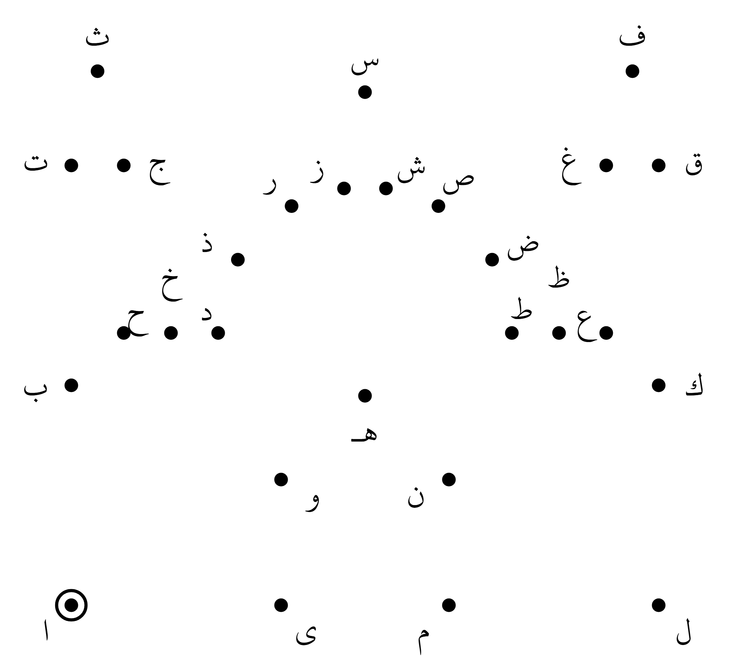

What did you draw? _____________________________ Now color it in!
IQRA 1447
Level 1 · Games
Name: ________________________________________
Connect the Dots 2 · Section 3 · Harakat — Start at the dot with a ring. Join the dots in this order, then join the last one back to the first.
بَ بُ بِ تَ تُ تِ ثَ ثُ ثِ جَ جُ جِ حَ حُ حِ خَ خُ خِ دَ دُ دِ ذَ ذُ ذِ رَ رُ رِ
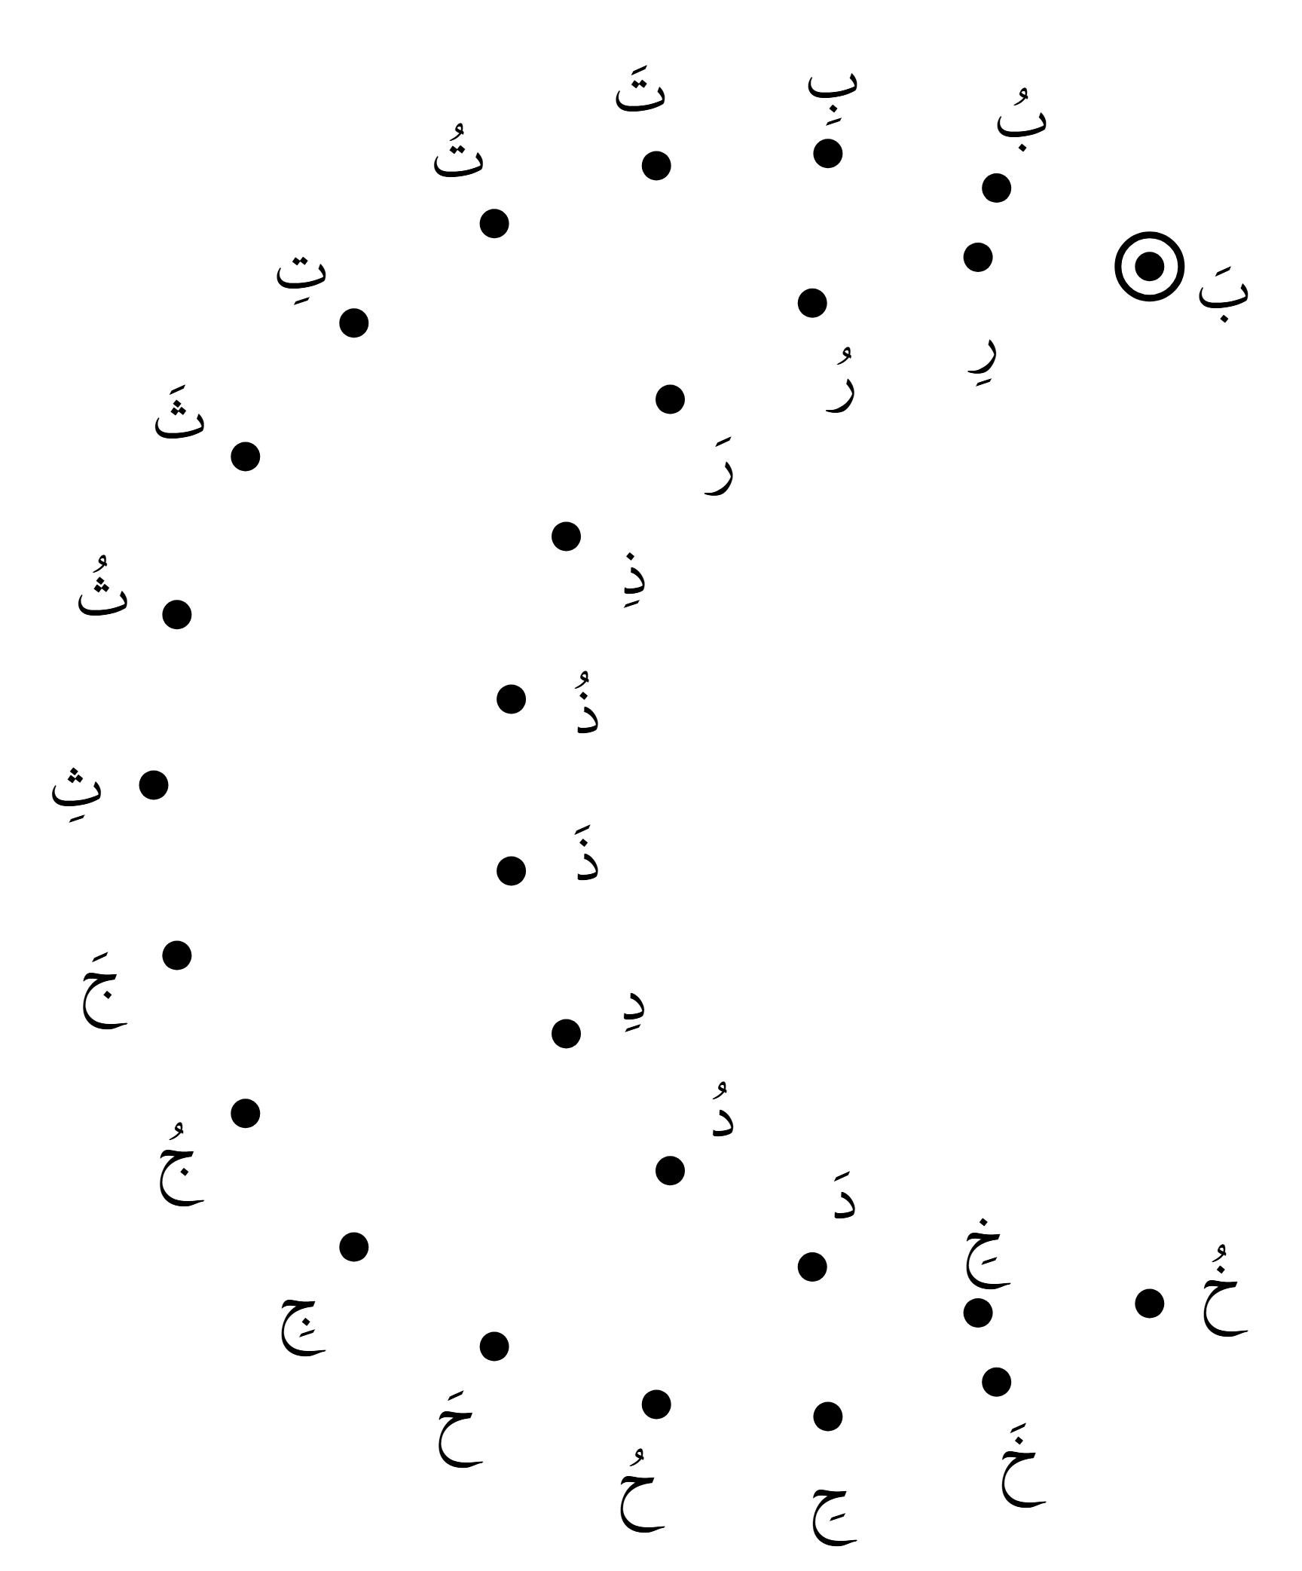

What did you draw? _____________________________ Now color it in!
IQRA 1447
Level 1 · Games
Name: ________________________________________
Connect the Dots 3 · Section 4 · Tanween — Start at the dot with a ring. Join the dots in this order, then join the last one back to the first.
بًا بٌ بٍ تًا تٌ تٍ ثًا ثٌ ثٍ جًا جٌ جٍ حًا حٌ حٍ خًا خٌ خٍ دًا دٌ دٍ ذًا ذٌ ذٍ
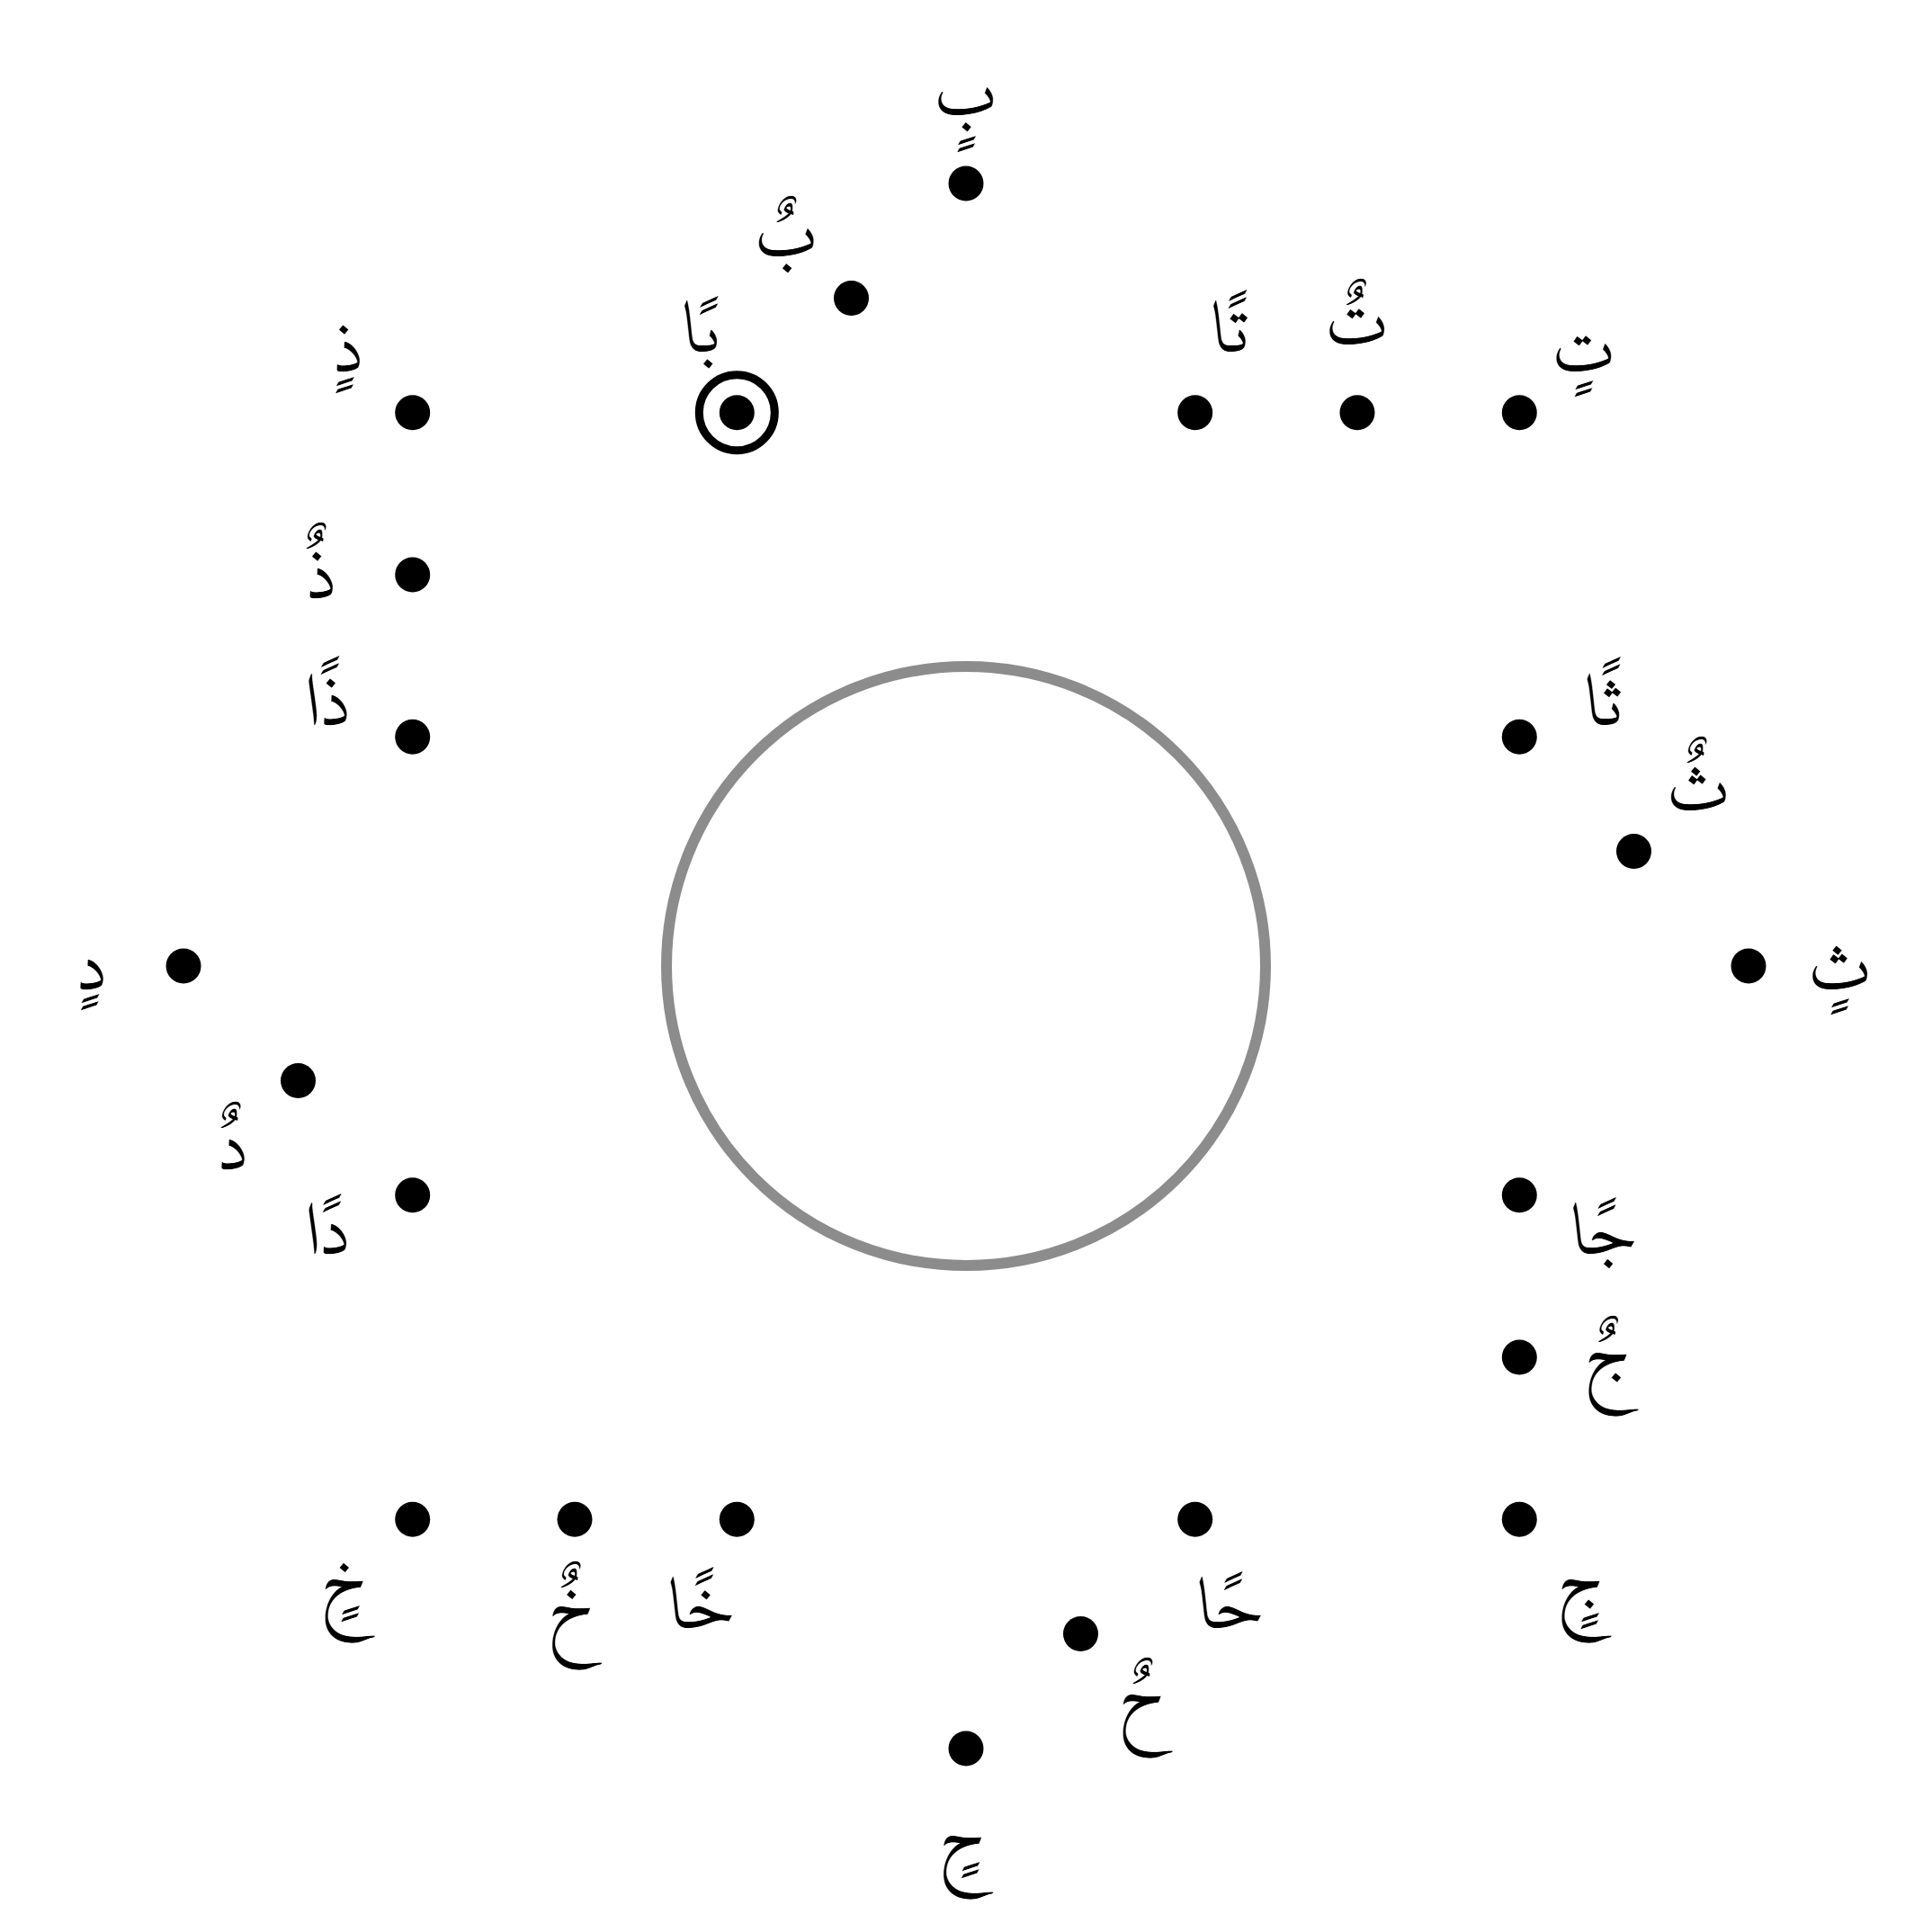

What did you draw? _____________________________ Now color it in!

